A Comprehensive Report on OpenCV

1. Introduction to OpenCV
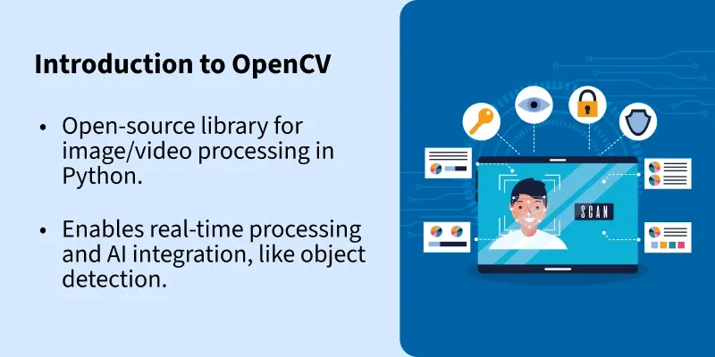
OpenCV (Open Source Computer Vision Library) is one of the most popular and powerful open-source libraries used for computer vision and image processing applications. Initially developed by Intel in 1999, OpenCV has grown into a widely adopted framework supported by a large community of developers and researchers. It provides tools for real-time image processing and is extensively used in fields such as artificial intelligence, robotics, surveillance systems, autonomous vehicles, medical imaging, and augmented reality.
OpenCV supports multiple programming languages including Python, C++, Java, and MATLAB interfaces. Among these, Python has become the most popular due to its simplicity, readability, and strong integration with other scientific libraries such as NumPy, Matplotlib, and TensorFlow. The library is optimized for real-time applications and includes more than 2500 optimized algorithms for image and video analysis.
The main objectives of OpenCV are to provide a common infrastructure for computer vision applications and to accelerate the use of machine perception in commercial products. OpenCV enables developers to perform tasks such as image filtering, object detection, face recognition, motion tracking, and feature extraction with minimal effort.
This report focuses on introducing OpenCV, explaining its installation process on Windows, setting it up using the Anaconda environment, and exploring essential OpenCV functions required for beginners.

2. Features and Applications of OpenCV
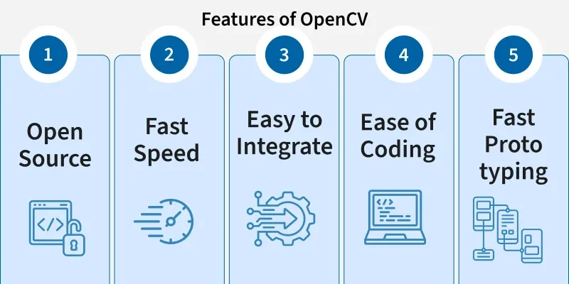
OpenCV provides a wide range of features that make it suitable for both academic research and industrial applications. Some of its key features include:
- Real-time image and video processing
- Machine learning and deep learning support
- Object detection and recognition
- Image transformations and filtering
- Camera calibration and 3D reconstruction
- 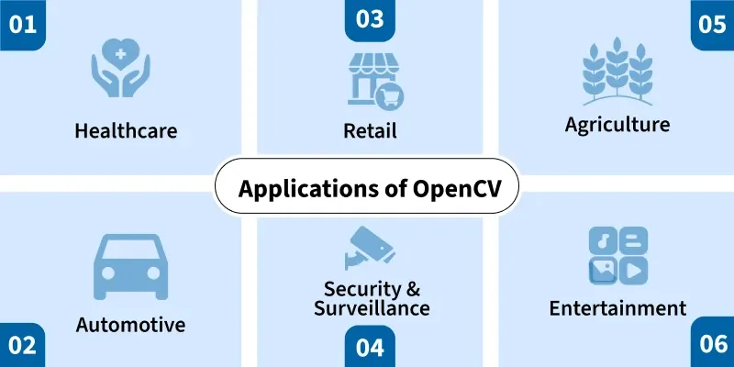
OpenCV is widely used in applications such as:
- Face recognition systems
- Motion detection and surveillance
- Autonomous driving systems
- Medical image analysis
- Gesture recognition
Due to its speed and efficiency, OpenCV is often integrated into embedded systems and mobile applications.

3. Installing OpenCV for Python on Windows
Installing OpenCV for Python on Windows is a straightforward process. Python users generally prefer using package managers like pip to simplify installation.

3.1 System Requirements
- Windows 10 or later
- Python 3.7 or higher
- Internet connection

3.2 Installation Steps
- Open Command Prompt
Upgrade pip using the command:
python -m pip install --upgrade pip

- Install OpenCV using:
pip install opencv-python

- Verify installation:
import cv2
print(cv2.__version__)
- If OpenCV is installed successfully, the version number will be displayed.

4. Common Installation Issues and Solutions
During installation, users may face issues such as missing dependencies or incompatible Python versions. These problems can be resolved by:
- Ensuring Python is added to the system PATH
- Using a virtual environment
- Installing the correct Python version
For advanced features like video support, users can install:
pip install opencv-contrib-python

5. Setting Up OpenCV with Anaconda Environment
Anaconda is a popular Python distribution used for data science and machine learning. It simplifies package management and environment handling.

5.1 Creating an Anaconda Environment
- Open Anaconda Prompt
Create a new environment:
conda create -n opencv_env python=3.9

- Activate the environment:
conda activate opencv_env

5.2 Installing OpenCV in Anaconda
Install OpenCV using:
pip install opencv-python

or
conda install -c conda-forge opencv

Using Anaconda helps avoid dependency conflicts and keeps projects isolated.

6. Verifying OpenCV Installation in Anaconda
To verify:
import cv2
print(cv2.__version__)

A successful output confirms proper setup.

7. Essential OpenCV Functions
OpenCV provides numerous functions that are essential for image processing tasks. Some of the most commonly used functions are described below.

7.1 Reading and Displaying Images
img = cv2.imread("image.jpg")
cv2.imshow("Image", img)
cv2.waitKey(0)
cv2.destroyAllWindows()

7.2 Converting Color Spaces
gray = cv2.cvtColor(img, cv2.COLOR_BGR2GRAY)

7.3 Image Resizing
resized = cv2.resize(img, (300, 300))

7.4 Drawing Shapes
cv2.rectangle(img, (50,50), (200,200), (0,255,0), 2)

8. Image Processing Techniques
OpenCV supports various image processing techniques such as:
- Blurring and smoothing
- Edge detection (Canny)
- Thresholding
- Morphological operations
Example of edge detection:
edges = cv2.Canny(gray, 100, 200)

9. Video Processing Using OpenCV
OpenCV can process video frames in real time.
cap = cv2.VideoCapture(0)
while True:
ret, frame = cap.read()
cv2.imshow("Video", frame)
if cv2.waitKey(1) == 27:
break
cap.release()
cv2.destroyAllWindows()

This is useful for surveillance and real-time detection systems.

10. Conclusion
OpenCV is a powerful and versatile computer vision library that plays a crucial role in modern image processing and artificial intelligence applications. Its ease of use, extensive documentation, and strong community support make it ideal for beginners and professionals alike. Installing OpenCV on Windows using Python or Anaconda is simple and efficient. Understanding essential OpenCV functions provides a strong foundation for developing advanced computer vision applications. As technology continues to evolve, OpenCV will remain a key tool in computer vision research and development.

